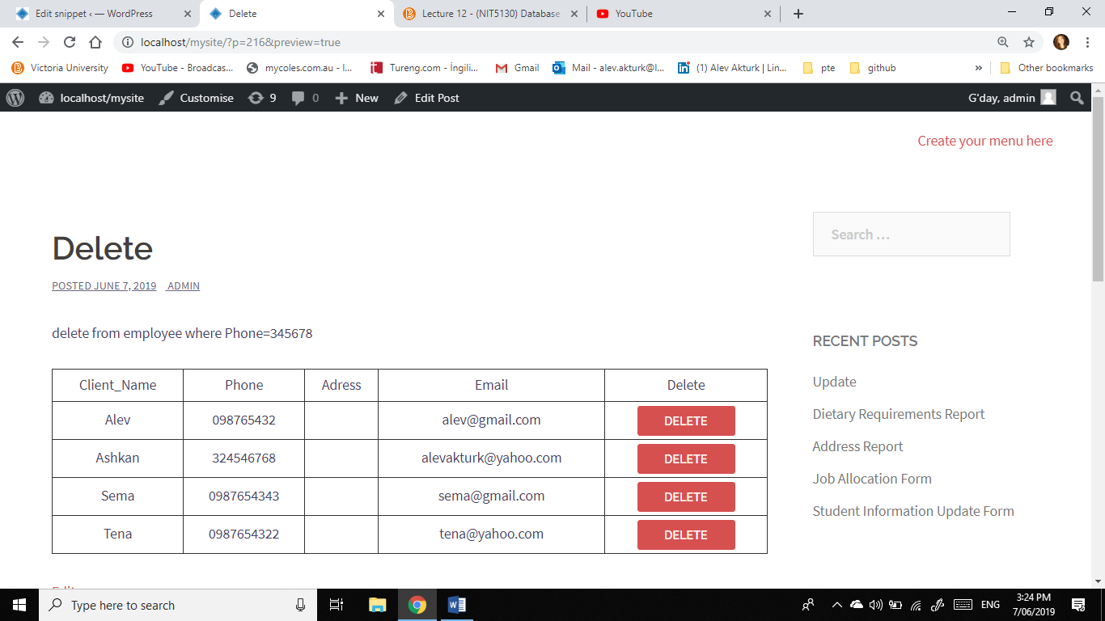s4584569 Alev Akturk Tutorial 12

Before Delete  
  
  
After Delete

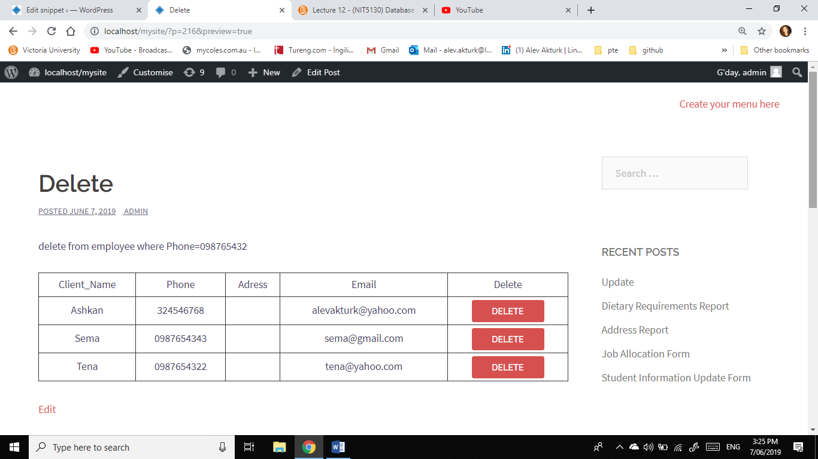

$mdebug=1;

/* 1. connct to the database

---------------------------------*/

$server="localhost";

$username="root";

$password="";

$db="week12";

$random_n=rand(0,100000); //submitted form has a different random number

$companydb = new wpdb($username,$password,$db,$server);

if ($companydb==null)

echo "DB Connection failed. Check your database connection account.<br>";

else

{

delete($companydb,$mdebug, $random_n);

select_display_withdeletebutton($companydb,$mdebug, $random_n);

}

function delete_form($random_n,$Phone)

{

$site_url=get_site_url();

$actionPage=""; //call itself

echo " <form style='margin: 0; padding: 0;' method='post' action='$actionPage' >";

echo "<input type='hidden' name='Phone' value='$Phone' /> ";

echo "<input type='hidden' name='random_n' value='$random_n' /> ";

echo "<button style='padding:0; vertical-align:middle; height:33px; width:110px;' type=submit> Delete </button> ";

echo "</form>";

}

function delete($companydb,$mdebug, $random_n)

{

$form_random_n=$_POST["random_n"];

if ($form_random_n!=null && $form_random_n!=$random_n)

{

$Phone=$_POST["Phone"];

$qstr="delete from employee where Phone=$Phone";

echo "$qstr<br><br>";

$companydb->query($qstr);

}

}

function select_display_withdeletebutton($companydb,$mdebug,$random_n)

{

$qstr="select * from employee order by Client_Name";

$rows = $companydb->get_results($qstr);

if($rows==null)

echo "No record found in query: $qstr <br>";

/* 3. display data in web page table

--------------------------------------*/

else

{

$field_num=4;

$field_names=array("Client_Name","Phone","Adress","Email");

$display_names=array("Client_Name","Phone","Adress","Email");

echo "<table border=1><tr>";

for($i=0;$i<$field_num;$i++)

echo "<td>$display_names[$i] </td>";

echo "<td>Delete</td>";

echo "</tr>";

foreach ($rows as $row)

{

echo "<tr>";

for($i=0;$i<$field_num;$i++)

{

$field_name=$field_names[$i];

$field_data=$row->$field_name;

echo "<td>$field_data </td>";

}

echo "<td>";

delete_form($random_n,$row->Phone);

echo "</td>";

echo "</tr>";

}

}

echo "</table>";

}